Part 1:
sudo dhclient -r

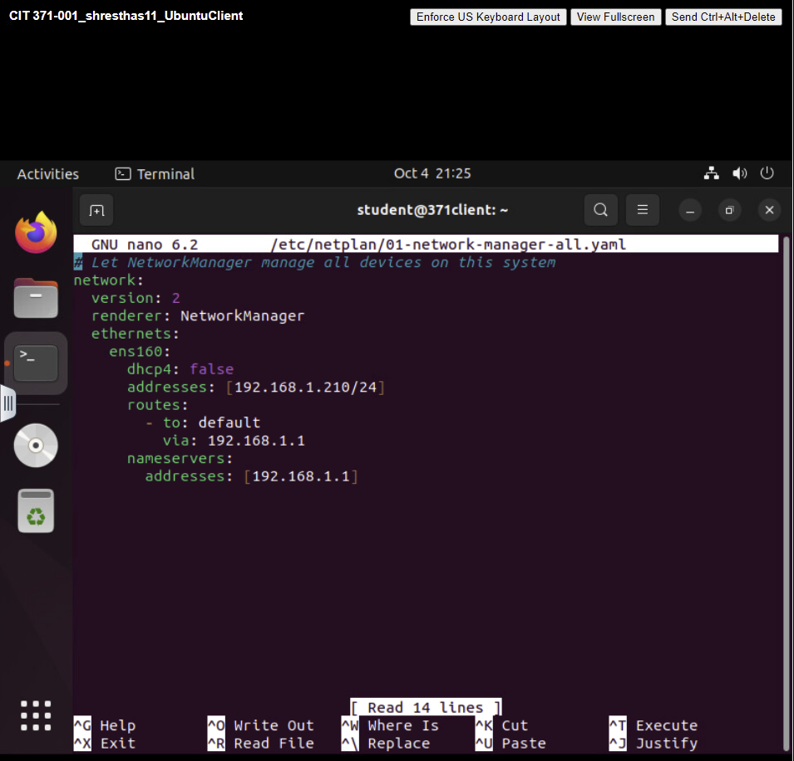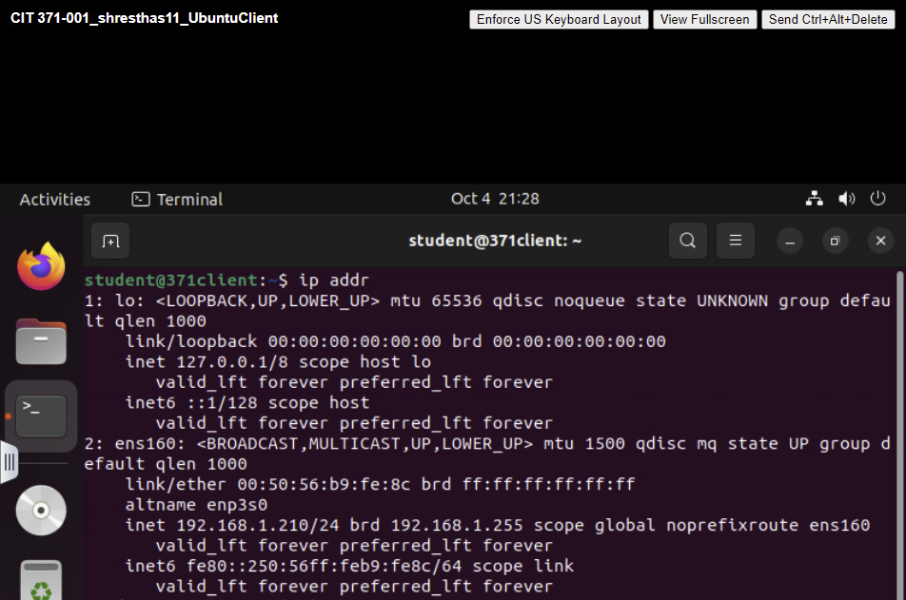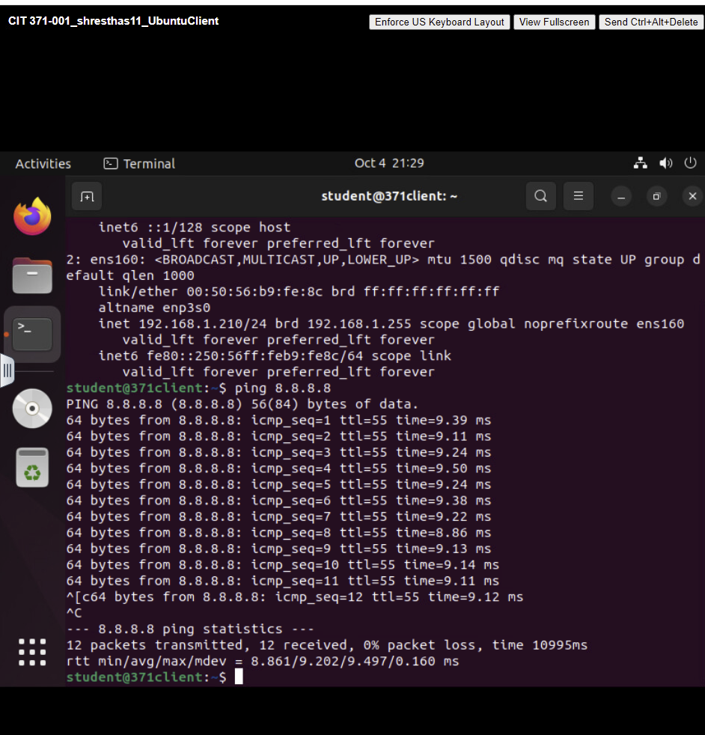

Part 2:
\#!/bin/bash

run_ping() {
read -p "Enter an IP address or hostname to ping: " target
while true; do
read -p "Enter the number of requests to send: " count
if [[ $count =~ ^[0-9]+$ ]]; then
ping -c $count $address
break
else
echo "Please enter a valid integer."
fi
done
}

run_tracepath() {
read -p "Enter an IP address or hostname to trace: " target
timeout 10s tracepath "$target"
}

run_nslookup() {
read -p "Enter an IP address or hostname to lookup: " target
nslookup "$target"
}

run_netstat() {
netstat -r
}

run_arp() {
arp -e
}

while true; do
echo "Network Troubleshooting Tool"
echo "1. Ping"
echo "2. Tracepath"
echo "3. NSLookup"
echo "4. Netstat (Routing Table)"
echo "5. ARP Table"
echo "6. Clear Screen"
echo "7. Exit"
read -p "Enter your choice: " choice

case $choice in
1) run_ping ;;
2) run_tracepath ;;
3) run_nslookup ;;
4) run_netstat ;;
5) run_arp ;;
6) clear ;;
7) exit 0 ;;
*) echo "Invalid option. Please try again." ;;
esac

echo
read -p "Press Enter to continue..."
clear
Done

